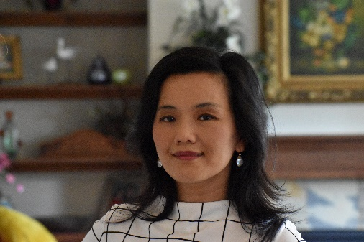
Dibin Lassila
Sr. HR Director and D&I Leader
Daikin Applied Americas
Dibin Lassila is Senior HR Director at Daikin Applied Americas (DAA), a division of Daikin Industries Limited, headquartered in Osaka, Japan. Based out of DAA’s headquarters in Plymouth, Minnesota, Dibin currently leads a team of HR professionals and supports DAA’s Operations group including plants, Quality, and Supply Chain. She is also the Diversity and Inclusion (D&I) Leader for DAA.
Dibin counts herself incredibly fortunate to have had a diverse background and solid track record to get her where she is today at DAA: a bachelor’s degree in economics (Shanghai, China), a master’s degree in Human Resources (University of South Carolina), some incredible HR experience working at Amazon and Honeywell, and a few years off to be a full-time mom while volunteering for non-profit organizations. Leading D&I is new to her, but she has applied strategic thinking, process discipline, learning and curiosity, and a healthy balance of passion and methodicalness. While still early in its D&I journey, DAA now has a well-defined D&I strategy and roadmap, and is well on its way to educating leaders and employees, influencing their hearts and minds, and infusing D&I into the fabric of the DAA culture and business.

