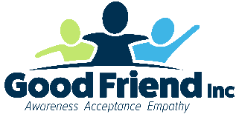

**Chelsea Budde**

Executive Director and Co-founder

Good Friend, Inc.

Chelsea Budde is the Executive Director and Co-founder of Good Friend, Inc., a nonprofit organization based in Waukesha, Wis., devoted to autism awareness, acceptance, and empathy. Her work inspiration comes from her two neurodivergent young adult children, whose journey has taught not only Chelsea, but through her Good Friend presentations, also more than 54,000 people how to better understand autistic neurology. In addition to being a trainer, she's also a writer, university guest lecturer, and conference presenter. While her bachelor's degree comes from St. Norbert College, her continuing education over the last 13 years with Good Friend has yielded the most valuable lessons.